

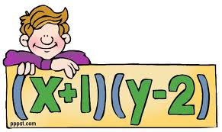

Sylwia Denko

Samantha McHugh

Chelsea Mueller

Jamie Ropars

Table of Contents

Section:

1. Materials
2. Focus Problem
3. K-1st Grade Problem 🡪 Patterns
4. 2nd-3rd Grade Problem 🡪Input-Output
5. 4th-5th Grade Problem 🡪 Variables
6. Standards
7. Reflection

Materials Needed for BIM

* Different Color Manipulatives
* Pattern Worksheet
* Scissors
* Glue
* Pencils
* Input/ Output Worksheet
* Variable Representation Worksheet
* Missing Variables Worksheet

Focus Problem



This word problem is recommended for small groups of middle school students. By completing this problem students will draw information from a word problem, use a formula to create an equation for an unknown variable, and manipulate the equations to find the unknown value.

**Materials:**

* **Missing Variables Worksheet**

Algebraic Reasoning

Animal Patterns

C:\Program Files (x86)\Microsoft Office\MEDIA\CAGCAT10\j0149627.wmf

Early Elementary School Activity

Grades K-1

K-1st Grade Problem

Patterns

The children will be given different color manipulatives to represent different animals in which they need to make different patterns and they will be asked to make their own pattern. Specifically they will be asked, “How did you know what comes next?”

Materials

* Different Color Manipulatives
* Pattern Worksheet
* Scissors
* Glue

The next step of this activity would be to give the students a worksheet that will allow them to practice completing different patterns. Students can use the manipulatives to represent the animals found on the worksheet. They will be able to look at the pattern and determine what comes next. Students will glue pictures in the missing space to show what comes next in each pattern. Later, they will be making their own patterns.

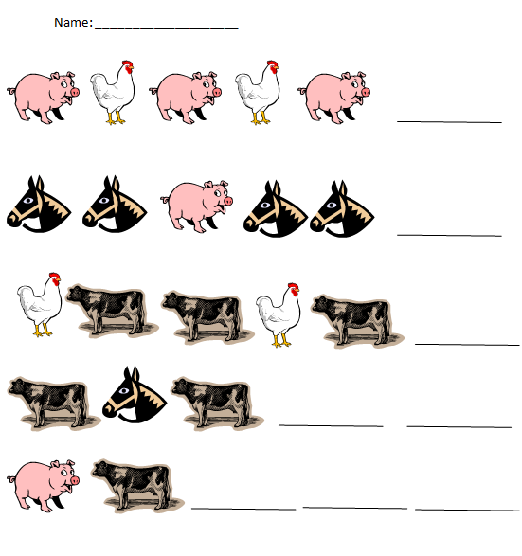

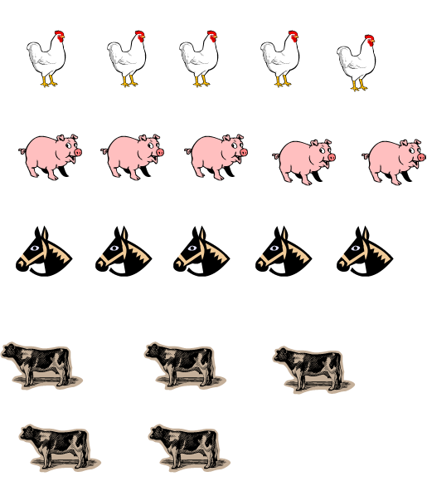

Questions students will be asked

1. How do you know that this is a pattern?
2. How do you know what comes next?
3. Using these two animals can you make a different pattern?

Follow Up Questions

1. How do you know each problem is a pattern?
2. What pattern is found in each individual problem? (example AAB or ABA)
3. How do you know what comes next?
4. Can you make your own pattern?

Teacher Reflection Questions

* Were students able to understand and find what comes next in each pattern?
* Were they able to determine the sequence of each pattern?

Algebraic Reasoning

Input and Output

C:\Program Files (x86)\Microsoft Office\MEDIA\CAGCAT10\j0149627.wmf

Elementary School Activity

Grades 2-3

2nd-3rd Grade Problem

Input/Output

Students will be given two worksheets, one at a time. Because we are working with the theme of farm animals, they will be trying to figure out how many legs there are for both chickens and cows with certain numbers provided. In the first worksheet, the students will be trying to figure out how many legs there are for the given amount of cows. In the second worksheet, it gets a little bit more challenging. The given number alternates between the number of chickens and the number of legs. Using the information given, the students need to fill out the function box. After completing the function box, the students are asked to write on what the rule is that was used. After that, the students need to create their own word problem by looking at their worksheet.

Materials:

* Two worksheets: Input and Output

Questions the Students will be asked:

1. Do you know how many legs a chicken and a cow have?
2. How can you use that information to find out how many chickens and/or cows there are?
3. If you know how many cows there are, how can you find out how many total legs there are?

Follow up Questions:

1. How can you prove that you have the right answer?
2. How did you come up with that?

Teacher Reflection Questions:

* Were the students able to find a rule for the function box?
* Were the students able to find a pattern in order to help them fill out the function box?
* Do the students fully understand the concept?

Name__________________________ Date _______________

Using the information given (the number of cows), fill out the function box with the number of legs there are for the number of cows and write down the rule on the bottom.

For example: When there is 1 cow there are 4 legs.

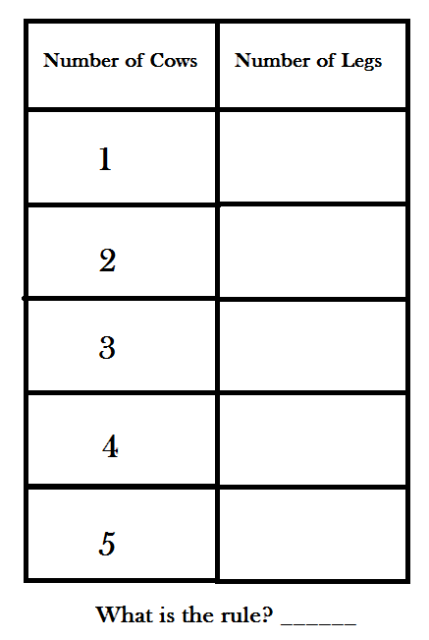

Name__________________________ Date _______________

Using the information given (number of chickens or number of legs) the function box below has the number of legs and number of chickens in two separate columns, complete the function box with the correct number of chickens or the correct number of legs depending on the number that is given. After that, write down the rule used on the bottom of the worksheet.

For example: When there are 3 chickens there are 6 legs.

When there are 12 legs, there are 6 chickens.

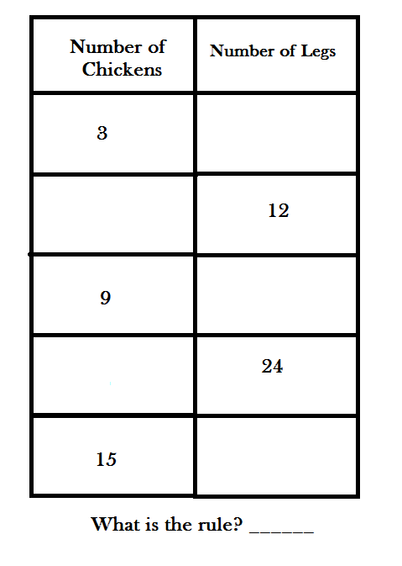

Answer Key: Worksheet #1

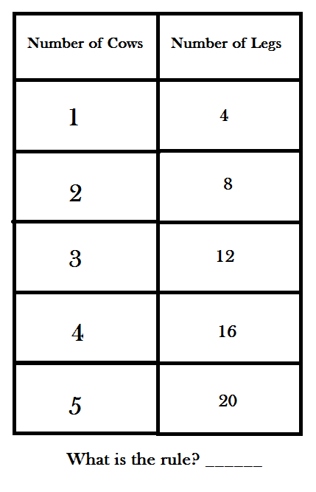

(Number of cow multiplied 4)

Answer Key: Worksheet #2

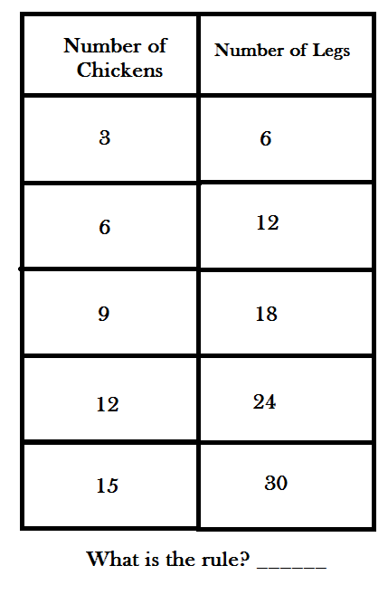

(Number chickens multiplied by 2 OR number of legs divided by 2)

Algebraic Reasoning

Variable Representation

C:\Program Files (x86)\Microsoft Office\MEDIA\CAGCAT10\j0149627.wmf

Upper Elementary School Activity

Grades 4-5

4th-5th Grade problem

Variable Representations and Equation Manipulation

For this lesson, students should be familiar with the idea of reversible operands. It would be prudent to practice problems in the following form to be sure that students will be able to manipulate the algebra equations.

65 + 15 = 80

65 ÷ 5 × 2 = 26

24/3 × 4 = 32

This whole class activity is great for the students to see variables. For this lesson you will need two worksheets for the students to complete. The blank boxes on the page represent the variable or function that the student must figure out.

Materials:

-The only materials needed for this lesson is the worksheet of questions for the students to answer

Questions the Students will be asked:

1.  Each cow has how many legs?

2.  How would you use the knowledge of how many cow legs there are to solve the word problem, what is the connection to solving the problem?

3.  You know each cow has 4 legs but how would you figure out how many total cows there were after finding out there were a total of 84 legs?

Follow up Questions:

1.  How can you be sure you came up with the correct total of cows?

2.  Explain the steps you took to get to your final answer.

Teacher Reflection Questions:

* Were the students able to use reversible operands?
* Were the students able to complete functions in subtraction, addition, multiplication, and division when missing parts of the problem?
* Was the objective of the lesson met with the students?

**Out on the FarmC:\Program Files (x86)\Microsoft Office\MEDIA\CAGCAT10\j0149627.wmf**

Farmer Joe walks out to his barn to check on his cows. When he gets to the double door he can only get the bottom half open. He needs to make sure all of his cows are in the barn so he decides to count their legs because that is all he can see. Farmer Joe comes to a total of 84 legs. How would you figure out how many cows are in the barn knowing there are a total of 84 legs and each cow has 4 legs?

**× 4 = 84**

**= ?**

**What does each open box represent?**

**836 - = 345 + 339 = 696**

**= ? = ?**

**36 5 = 180 1830 256 = 1574**

**= ? = ?**

**488 ÷ = 61 ÷ 4 = 60**

**= ? = ?**

**Answer Key**

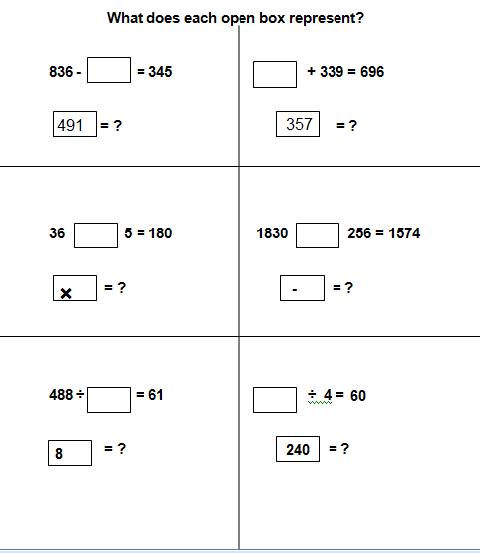

Algebraic Reasoning

Focus Problem



Middle School Activity

Grades 6-7

6th-7th Grade Problem

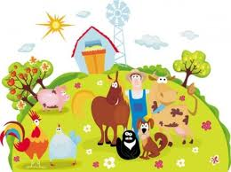

Farmer Joe has horses and chickens. There are a total of 150 legs on his farm and 55 animals. How many horses and chickens are on Farmer Joe’s farm?

1. Predict how many of each animal there will be and why.
2. Create two equations for this problem and explain why they will work.
3. Solve for the missing variables in your problem to obtain the amount of each animal on the farm.
4. Was your prediction correct? Explain

Questions the Students will be asked:

1. Make a few predictions before you begin.
2. Explain your predictions.
3. How can you start your equation?
4. How many variables are there?

Follow up Questions:

1. How did you know how to start your equation?
2. Did you have any difficulties?
3. How did you figure this out?
4. Was your prediction correct?

Teacher Reflection Question:

* Were the students able to create the equations with two unknown variables?
* Were the students able to solve for both missing variables?

Answer Key

Equations:

h+c=55

4h+2c=150

h=horse

c=chicken

Total amount of animals on farm=55

Total amount of animal legs=150

Horses have 4 legs

Chickens have 2 legs

How to Solve:

h+c=55 Equation 1

c=55-h Change to solve for c to use in Equation 2

4h+2c=150 Equation 2

4h+2(55-h)=150 Plug in manipulated Equation 1 (c=..)

4h+110-2h=150 Simplify

2h+110=150 Simplify

2h=40 Simplify

h=20 Solve for h

h+c=55 Equation 1

20+c=55 Plug in h

C=35 Solve for c

h+c=55 Equation 1

h=55-c Change to solve for h to use in Equation 2

4h+2c=150 Equation 2

4(55-c)+2c=150 Plug in manipulation Equation 1 (h=..)

220-4c+2c=150 Simplify

220-2c=150 Simplify

-2c=-70 Simplify

c=35 Solve for c

h+c=55 Equation 1

h+35=55 Plug in c

h=20 Solve for h

Common Core State Standards

**Kindergarten**

**Understand addition, and understand subtraction.**

* CCSS.Math.Content.K.OA.A.1 Represent addition and subtraction with objects, fingers, mental images, drawings1, sounds (e.g., claps), acting out situations, verbal explanations, expressions, or equations.
* CCSS.Math.Content.K.OA.A.2 Solve addition and subtraction word problems, and add and subtract within 10, e.g., by using objects or drawings to represent the problem.
* CCSS.Math.Content.K.OA.A.3 Decompose numbers less than or equal to 10 into pairs in more than one way, e.g., by using objects or drawings, and record each decomposition by a drawing or equation (e.g., 5 = 2 + 3 and 5 = 4 + 1).
* CCSS.Math.Content.K.OA.A.4 For any number from 1 to 9, find the number that makes 10 when added to the given number, e.g., by using objects or drawings, and record the answer with a drawing or equation.
* CCSS.Math.Content.K.OA.A.5 Fluently add and subtract within 5.

**Grade 1**

**Represent and solve problems involving addition and subtraction.**

* CCSS.Math.Content.1.OA.A.1 Use addition and subtraction within 20 to solve word problems involving situations of adding to, taking from, putting together, taking apart, and comparing, with unknowns in all positions, e.g., by using objects, drawings, and equations with a symbol for the unknown number to represent the problem.1
* CCSS.Math.Content.1.OA.A.2 Solve word problems that call for addition of three whole numbers whose sum is less than or equal to 20, e.g., by using objects, drawings, and equations with a symbol for the unknown number to represent the problem.

**Understand and apply properties of operations and the relationship between addition and subtraction.**

* CCSS.Math.Content.1.OA.B.3 Apply properties of operations as strategies to add and subtract.2 Examples: If 8 + 3 = 11 is known, then 3 + 8 = 11 is also known. (Commutative property of addition.) To add 2 + 6 + 4, the second two numbers can be added to make a ten, so 2 + 6 + 4 = 2 + 10 = 12. (Associative property of addition.)
* CCSS.Math.Content.1.OA.B.4 Understand subtraction as an unknown-addend problem. For example, subtract 10 – 8 by finding the number that makes 10 when added to 8.

**Add and subtract within 20.**

* CCSS.Math.Content.1.OA.C.5 Relate counting to addition and subtraction (e.g., by counting on 2 to add 2).
* CCSS.Math.Content.1.OA.C.6 Add and subtract within 20, demonstrating fluency for addition and subtraction within 10. Use strategies such as counting on; making ten (e.g., 8 + 6 = 8 + 2 + 4 = 10 + 4 = 14); decomposing a number leading to a ten (e.g., 13 – 4 = 13 – 3 – 1 = 10 – 1 = 9); using the relationship between addition and subtraction (e.g., knowing that 8 + 4 = 12, one knows 12 – 8 = 4); and creating equivalent but easier or known sums (e.g., adding 6 + 7 by creating the known equivalent 6 + 6 + 1 = 12 + 1 = 13).

**Work with addition and subtraction equations.**

* CCSS.Math.Content.1.OA.D.7 Understand the meaning of the equal sign, and determine if equations involving addition and subtraction are true or false. For example, which of the following equations are true and which are false? 6 = 6, 7 = 8 – 1, 5 + 2 = 2 + 5, 4 + 1 = 5 + 2.
* CCSS.Math.Content.1.OA.D.8 Determine the unknown whole number in an addition or subtraction equation relating three whole numbers. For example, determine the unknown number that makes the equation true in each of the equations 8 + ? = 11, 5 = _ – 3, 6 + 6 = _.

**Grade 2**

**Represent and solve problems involving addition and subtraction.**

* CCSS.Math.Content.2.OA.A.1 Use addition and subtraction within 100 to solve one- and two-step word problems involving situations of adding to, taking from, putting together, taking apart, and comparing, with unknowns in all positions, e.g., by using drawings and equations with a symbol for the unknown number to represent the problem.1

**Add and subtract within 20.**

* CCSS.Math.Content.2.OA.B.2 Fluently add and subtract within 20 using mental strategies.2 By end of Grade 2, know from memory all sums of two one-digit numbers.

**Work with equal groups of objects to gain foundations for multiplication.**

* CCSS.Math.Content.2.OA.C.3 Determine whether a group of objects (up to 20) has an odd or even number of members, e.g., by pairing objects or counting them by 2s; write an equation to express an even number as a sum of two equal addends.
* CCSS.Math.Content.2.OA.C.4 Use addition to find the total number of objects arranged in rectangular arrays with up to 5 rows and up to 5 columns; write an equation to express the total as a sum of equal addends.

**Grade 3**

**Represent and solve problems involving multiplication and division.**

* CCSS.Math.Content.3.OA.A.1 Interpret products of whole numbers, e.g., interpret 5 × 7 as the total number of objects in 5 groups of 7 objects each. For example, describe a context in which a total number of objects can be expressed as 5 × 7.
* CCSS.Math.Content.3.OA.A.2 Interpret whole-number quotients of whole numbers, e.g., interpret 56 ÷ 8 as the number of objects in each share when 56 objects are partitioned equally into 8 shares, or as a number of shares when 56 objects are partitioned into equal shares of 8 objects each. For example, describe a context in which a number of shares or a number of groups can be expressed as 56 ÷ 8.
* CCSS.Math.Content.3.OA.A.3 Use multiplication and division within 100 to solve word problems in situations involving equal groups, arrays, and measurement quantities, e.g., by using drawings and equations with a symbol for the unknown number to represent the problem.1
* CCSS.Math.Content.3.OA.A.4 Determine the unknown whole number in a multiplication or division equation relating three whole numbers. For example, determine the unknown number that makes the equation true in each of the equations 8 × ? = 48, 5 = _ ÷ 3, 6 × 6 = ?

**Understand properties of multiplication and the relationship between multiplication and division.**

* CCSS.Math.Content.3.OA.B.5 Apply properties of operations as strategies to multiply and divide.2 Examples: If 6 × 4 = 24 is known, then 4 × 6 = 24 is also known. (Commutative property of multiplication.) 3 × 5 × 2 can be found by 3 × 5 = 15, then 15 × 2 = 30, or by 5 × 2 = 10, then 3 × 10 = 30. (Associative property of multiplication.) Knowing that 8 × 5 = 40 and 8 × 2 = 16, one can find 8 × 7 as 8 × (5 + 2) = (8 × 5) + (8 × 2) = 40 + 16 = 56. (Distributive property.)
* CCSS.Math.Content.3.OA.B.6 Understand division as an unknown-factor problem. For example, find 32 ÷ 8 by finding the number that makes 32 when multiplied by 8.

**Multiply and divide within 100.**

* CCSS.Math.Content.3.OA.C.7 Fluently multiply and divide within 100, using strategies such as the relationship between multiplication and division (e.g., knowing that 8 × 5 = 40, one knows 40 ÷ 5 = 8) or properties of operations. By the end of Grade 3, know from memory all products of two one-digit numbers.

**Solve problems involving the four operations, and identify and explain patterns in arithmetic.**

* CCSS.Math.Content.3.OA.D.8 Solve two-step word problems using the four operations. Represent these problems using equations with a letter standing for the unknown quantity. Assess the reasonableness of answers using mental computation and estimation strategies including rounding.3
* CCSS.Math.Content.3.OA.D.9 Identify arithmetic patterns (including patterns in the addition table or multiplication table), and explain them using properties of operations. For example, observe that 4 times a number is always even, and explain why 4 times a number can be decomposed into two equal addends.

**Grade 4**

**Use the four operations with whole numbers to solve problems.**

* CCSS.Math.Content.4.OA.A.1 Interpret a multiplication equation as a comparison, e.g., interpret 35 = 5 × 7 as a statement that 35 is 5 times as many as 7 and 7 times as many as 5. Represent verbal statements of multiplicative comparisons as multiplication equations.
* CCSS.Math.Content.4.OA.A.2 Multiply or divide to solve word problems involving multiplicative comparison, e.g., by using drawings and equations with a symbol for the unknown number to represent the problem, distinguishing multiplicative comparison from additive comparison.1
* CCSS.Math.Content.4.OA.A.3 Solve multistep word problems posed with whole numbers and having whole-number answers using the four operations, including problems in which remainders must be interpreted. Represent these problems using equations with a letter standing for the unknown quantity. Assess the reasonableness of answers using mental computation and estimation strategies including rounding.

**Gain familiarity with factors and multiples.**

* CCSS.Math.Content.4.OA.B.4 Find all factor pairs for a whole number in the range 1–100. Recognize that a whole number is a multiple of each of its factors. Determine whether a given whole number in the range 1–100 is a multiple of a given one-digit number. Determine whether a given whole number in the range 1–100 is prime or composite.

**Generate and analyze patterns.**

* CCSS.Math.Content.4.OA.C.5 Generate a number or shape pattern that follows a given rule. Identify apparent features of the pattern that were not explicit in the rule itself. For example, given the rule “Add 3” and the starting number 1, generate terms in the resulting sequence and observe that the terms appear to alternate between odd and even numbers. Explain informally why the numbers will continue to alternate in this way.

**Grade 5**

**Write and interpret numerical expressions.**

* CCSS.Math.Content.5.OA.A.1 Use parentheses, brackets, or braces in numerical expressions, and evaluate expressions with these symbols.
* CCSS.Math.Content.5.OA.A.2 Write simple expressions that record calculations with numbers, and interpret numerical expressions without evaluating them. For example, express the calculation “add 8 and 7, then multiply by 2” as 2 × (8 + 7). Recognize that 3 × (18932 + 921) is three times as large as 18932 + 921, without having to calculate the indicated sum or product.

**Analyze patterns and relationships.**

* CCSS.Math.Content.5.OA.B.3 Generate two numerical patterns using two given rules. Identify apparent relationships between corresponding terms. Form ordered pairs consisting of corresponding terms from the two patterns, and graph the ordered pairs on a coordinate plane. For example, given the rule “Add 3” and the starting number 0, and given the rule “Add 6” and the starting number 0, generate terms in the resulting sequences, and observe that the terms in one sequence are twice the corresponding terms in the other sequence. Explain informally why this is so.

**Grade 6**

**Apply and extend previous understandings of arithmetic to algebraic expressions.**

* CCSS.Math.Content.6.EE.A.1 Write and evaluate numerical expressions involving whole-number exponents.
* CCSS.Math.Content.6.EE.A.2 Write, read, and evaluate expressions in which letters stand for numbers.
* CCSS.Math.Content.6.EE.A.2a Write expressions that record operations with numbers and with letters standing for numbers. For example, express the calculation “Subtract y from 5” as 5 – y.
* CCSS.Math.Content.6.EE.A.2b Identify parts of an expression using mathematical terms (sum, term, product, factor, quotient, coefficient); view one or more parts of an expression as a single entity. For example, describe the expression 2 (8 + 7) as a product of two factors; view (8 + 7) as both a single entity and a sum of two terms.
* CCSS.Math.Content.6.EE.A.2c Evaluate expressions at specific values of their variables. Include expressions that arise from formulas used in real-world problems. Perform arithmetic operations, including those involving whole-number exponents, in the conventional order when there are no parentheses to specify a particular order (Order of Operations). For example, use the formulas V = s3 and A = 6 s2 to find the volume and surface area of a cube with sides of length s = 1/2.
* CCSS.Math.Content.6.EE.A.3 Apply the properties of operations to generate equivalent expressions. For example, apply the distributive property to the expression 3 (2 + x) to produce the equivalent expression 6 + 3x; apply the distributive property to the expression 24x + 18y to produce the equivalent expression 6 (4x + 3y); apply properties of operations to y + y + y to produce the equivalent expression 3y.
* CCSS.Math.Content.6.EE.A.4 Identify when two expressions are equivalent (i.e., when the two expressions name the same number regardless of which value is substituted into them). For example, the expressions y + y + y and 3y are equivalent because they name the same number regardless of which number y stands for..

**Reason about and solve one-variable equations and inequalities.**

* CCSS.Math.Content.6.EE.B.5 Understand solving an equation or inequality as a process of answering a question: which values from a specified set, if any, make the equation or inequality true? Use substitution to determine whether a given number in a specified set makes an equation or inequality true.
* CCSS.Math.Content.6.EE.B.6 Use variables to represent numbers and write expressions when solving a real-world or mathematical problem; understand that a variable can represent an unknown number, or, depending on the purpose at hand, any number in a specified set.
* CCSS.Math.Content.6.EE.B.7 Solve real-world and mathematical problems by writing and solving equations of the form x + p = q and px = q for cases in which p, q and x are all nonnegative rational numbers.
* CCSS.Math.Content.6.EE.B.8 Write an inequality of the form x > c or x < c to represent a constraint or condition in a real-world or mathematical problem. Recognize that inequalities of the form x > c or x < c have infinitely many solutions; represent solutions of such inequalities on number line diagrams.

**Represent and analyze quantitative relationships between dependent and independent variables.**

* CCSS.Math.Content.6.EE.C.9 Use variables to represent two quantities in a real-world problem that change in relationship to one another; write an equation to express one quantity, thought of as the dependent variable, in terms of the other quantity, thought of as the independent variable. Analyze the relationship between the dependent and independent variables using graphs and tables, and relate these to the equation. For example, in a problem involving motion at constant speed, list and graph ordered pairs of distances and times, and write the equation d = 65t to represent the relationship between distance and time.

**Grade 7**

**Use properties of operations to generate equivalent expressions.**

* CCSS.Math.Content.7.EE.A.1 Apply properties of operations as strategies to add, subtract, factor, and expand linear expressions with rational coefficients.
* CCSS.Math.Content.7.EE.A.2 Understand that rewriting an expression in different forms in a problem context can shed light on the problem and how the quantities in it are related. For example, a + 0.05a = 1.05a means that “increase by 5%” is the same as “multiply by 1.05.”

**Solve real-life and mathematical problems using numerical and algebraic expressions and equations.**

* CCSS.Math.Content.7.EE.B.3 Solve multi-step real-life and mathematical problems posed with positive and negative rational numbers in any form (whole numbers, fractions, and decimals), using tools strategically. Apply properties of operations to calculate with numbers in any form; convert between forms as appropriate; and assess the reasonableness of answers using mental computation and estimation strategies. For example: If a woman making $25 an hour gets a 10% raise, she will make an additional 1/10 of her salary an hour, or $2.50, for a new salary of $27.50. If you want to place a towel bar 9 3/4 inches long in the center of a door that is 27 1/2 inches wide, you will need to place the bar about 9 inches from each edge; this estimate can be used as a check on the exact computation.
* CCSS.Math.Content.7.EE.B.4 Use variables to represent quantities in a real-world or mathematical problem, and construct simple equations and inequalities to solve problems by reasoning about the quantities.
* CCSS.Math.Content.7.EE.B.4a Solve word problems leading to equations of the form px + q = r and p(x + q) = r, where p, q, and r are specific rational numbers. Solve equations of these forms fluently. Compare an algebraic solution to an arithmetic solution, identifying the sequence of the operations used in each approach. For example, the perimeter of a rectangle is 54 cm. Its length is 6 cm. What is its width?
* CCSS.Math.Content.7.EE.B.4b Solve word problems leading to inequalities of the form px + q > r or px + q < r, where p, q, and r are specific rational numbers. Graph the solution set of the inequality and interpret it in the context of the problem. For example: As a salesperson, you are paid $50 per week plus $3 per sale. This week you want your pay to be at least $100. Write an inequality for the number of sales you need to make, and describe the solutions.

**Grade 8**

**Expressions and Equations Work with radicals and integer exponents.**

* CCSS.Math.Content.8.EE.A.1 Know and apply the properties of integer exponents to generate equivalent numerical expressions. For example, 32 × 3–5 = 3–3 = 1/33 = 1/27.
* CCSS.Math.Content.8.EE.A.2 Use square root and cube root symbols to represent solutions to equations of the form x2 = p and x3 = p, where p is a positive rational number. Evaluate square roots of small perfect squares and cube roots of small perfect cubes. Know that √2 is irrational.
* CCSS.Math.Content.8.EE.A.3 Use numbers expressed in the form of a single digit times an integer power of 10 to estimate very large or very small quantities, and to express how many times as much one is than the other. For example, estimate the population of the United States as 3 times 108 and the population of the world as 7 times 109, and determine that the world population is more than 20 times larger.
* CCSS.Math.Content.8.EE.A.4 Perform operations with numbers expressed in scientific notation, including problems where both decimal and scientific notation are used. Use scientific notation and choose units of appropriate size for measurements of very large or very small quantities (e.g., use millimeters per year for seafloor spreading). Interpret scientific notation that has been generated by technology

**Understand the connections between proportional relationships, lines, and linear equations.**

* CCSS.Math.Content.8.EE.B.5 Graph proportional relationships, interpreting the unit rate as the slope of the graph. Compare two different proportional relationships represented in different ways. For example, compare a distance-time graph to a distance-time equation to determine which of two moving objects has greater speed.
* CCSS.Math.Content.8.EE.B.6 Use similar triangles to explain why the slope m is the same between any two distinct points on a non-vertical line in the coordinate plane; derive the equation y = mx for a line through the origin and the equation y = mx + b for a line intercepting the vertical axis at b.

**Analyze and solve linear equations and pairs of simultaneous linear equations.**

* CCSS.Math.Content.8.EE.C.7 Solve linear equations in one variable.
* CCSS.Math.Content.8.EE.C.7a Give examples of linear equations in one variable with one solution, infinitely many solutions, or no solutions. Show which of these possibilities is the case by successively transforming the given equation into simpler forms, until an equivalent equation of the form x = a, a = a, or a = b results (where a and b are different numbers).
* CCSS.Math.Content.8.EE.C.7b Solve linear equations with rational number coefficients, including equations whose solutions require expanding expressions using the distributive property and collecting like terms.
* CCSS.Math.Content.8.EE.C.8 Analyze and solve pairs of simultaneous linear equations.
* CCSS.Math.Content.8.EE.C.8a Understand that solutions to a system of two linear equations in two variables correspond to points of intersection of their graphs, because points of intersection satisfy both equations simultaneously.
* CCSS.Math.Content.8.EE.C.8b Solve systems of two linear equations in two variables algebraically, and estimate solutions by graphing the equations. Solve simple cases by inspection. For example, 3x + 2y = 5 and 3x + 2y = 6 have no solution because 3x + 2y cannot simultaneously be 5 and 6.
* CCSS.Math.Content.8.EE.C.8c Solve real-world and mathematical problems leading to two linear equations in two variables. For example, given coordinates for two pairs of points, determine whether the line through the first pair of points intersects the line through the second pair.

BIM Reflection

The Big Idea Module (BIM) that we created was based on the mathematical concept of algebraic reasoning following the common core state standards for grades K-7. Algebra is a key part of mathematics and is used for basic arithmetic and representing patterns. It is important for students to understand that algebra includes the understanding of patterns, variables, the equal sign, and the idea that for every input there is a unique output. Our goal for this BIM is to have each lesson and activity feed into the next. It is important for students to have a good foundation and build on individual ideas to use them to expand their knowledge through each activity of algebraic reasoning.

We begin preparing students with the introduction of a basic algebraic reasoning by having students discover different patterns. Students in kindergarten and first grade will understand the process of finding and creating new patterns. The students will be given a manipulative and be asked to use these as representations to create different patterns. The activity will allow for students to visually see different patterns and determine what comes next in each pattern. Students will also need to create a pattern of their own so we are able to see their understanding of patterns and what comes next. The common core standard that relates to this problem is K.OA.1, represent addition with objects, fingers, mental images, drawings, sounds, acting out situations, verbal explanations, or equations. Students will be able to use animal manipulatives to create patterns and determine what comes next in a given pattern.

Our next activity is geared toward students of second and third grade. Because the previous problem had to do with patterns we created a problem where students could use their knowledge of patterns and integrate those ideas to help them solve the problem. Students will be able to understand the use of the function box to find both input and output variables. Students will be trying to figure out how many legs the chickens and cows have when the given number is there. Then they will complete the function box with correct number of chickens or the correct number of legs according to the number that is given. Using the knowledge of patterns and understanding of the function box students will be able to figure out the rule to each function box.

The standards that specifically relate to this problem are: CCSS.Math.Content.2.OA.B.2 Fluently add and subtract within 20 using mental strategies.2 By end of Grade 2, know from memory all sums of two one-digit numbers because when they have the first worksheet, they will be looking at the number of cows and trying to figure out the number of legs. They know that one cow has four legs but then when they get to two cows that have four legs each they will need to add 4 + 4 and so on. Eventually, this should create a foundation for multiplication. The function box related exactly to: CCSS.Math.Content.2.OA.C.4 Use addition to find the total number of objects arranged in rectangular arrays with up to 5 rows and up to 5 columns; write an equation to express the total as a sum of equal addends. They will be filling in a function box and writing the rule (equation). The second worksheet relates to: CCSS.Math.Content.3.OA.A.2 Interpret whole-number quotients of whole numbers, e.g., interpret 56 ÷ 8 as the number of objects in each share when 56 objects are partitioned equally into 8 shares, or as a number of shares when 56 objects are partitioned into equal shares of 8 objects each. For example, describe a context in which a number of shares or a number of groups can be expressed as 56 ÷ 8. In some cases they will be diving the number of legs to get the number of chickens

The next activity was created for students in grades four and five. After understanding patterns and the function box students will be able continue with their algebraic knowledge and understand variable representations and equation manipulation. With this problem, students should be familiar with the idea of reversible operands. It is important for students to practice these problems in this form to be sure that they will be able to manipulate the algebraic equations. They will look at each equation and determine the missing value or mathematical sign that should be put in the box. This follows the previous activity because students are asked to use patterns and find the missing numbers and signs in each number sentence. They will also be following the activity by having the students understand how many cows there are based on a given number of legs.

Our focus problem is a word problem that is recommended for small groups of middle school students grades six and seven. By completing this problem students will draw information from a word problem, use a formula to create an equation for an unknown variable and manipulate the equations to find the unknown value. This relates to the this common core standard: CCSS.Math.Content.6.EE.A.2 Write, read, and evaluate expressions in which letters stand for numbers. Students will be introduced to the problem of figuring out how many chicken and horses there are based on a total number of legs. They will predict how many of each animal they think there will be and why. Then, the students will create equations based on the information given in the problem. After the students create equations they will solve for the missing variables. Finally, the students will determine if their prediction was accurate. By completing all of these steps the students will be able to evaluate expressions in which letters stand for numbers. All of the previous problems and activities will lead to this final focus problem because students will understand the use of patterns, input and output using a function box and they will be able to create equations using variables and missing values.

For each of the problems we used the FERA cycle and gave the students an opportunity to focus by being by looking at a question/problem that we want them to think about and solve, explore the problem, reflect by seeing how they figured it out and giving reasoning behind their work, and apply their knowledge. By following these steps we hope to ensure that the students have mastered the skill that we want them to be understanding. After thinking, practicing, looking back, and applying it in the future, the students should understand. If our BIM project is completed through each grade students will gain an understanding of smaller pieces to help them complete the final focus problem. Students will learn patterns, input and output, variables, and in the end, they will understand how to solve for the missing variables using all they have previously learned in the other activities. Algebraic reasoning should be learned in steps and each step builds on one another. Following the core common standards and ideas of algebraic reasoning we were able to come up with a group of activities to help students gain knowledge and understanding of this topic to help them in future math experiences.

It was interesting to look at different grades and see how one skill builds upon another to a very high-leveled problem. Sometimes, as beginning teachers, we do not realize what grades should be learning what skills. This project has made us see how skills are connected and different ways to build up to one big skill. It shows how essential learning basic math is in the lower grades because without it, high-level thinking cannot be accomplished.